Nonfiction Text Features

Station 1
Caption

Nonfiction Text Features

Station 2
Title Page

Nonfiction Text Features

Station 3
Table of Contents

Nonfiction Text Features

Station 4
Diagram and Labels

Nonfiction Text Features

Station 5
Chart, Graph, or Table
Pie Chart
Table
Nonfiction Text Features

Station 6
Glossary

Nonfiction Text Features

Station 7
Bolded Words
Bolded Word
Glossary
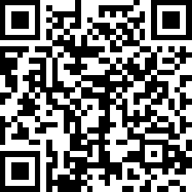
Nonfiction Text Features

Station 8
Heading
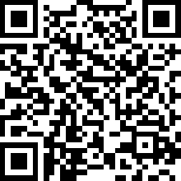

Nonfiction Text Features

Station 9
Index

