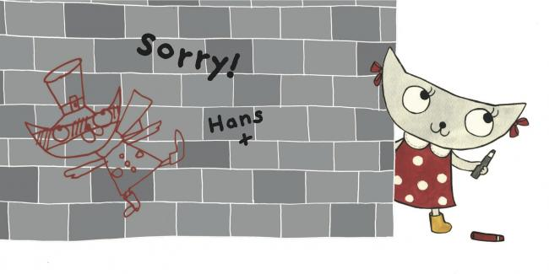

**The main idea of Matilda and Hans is:**

Create a new disguise for Matilda!