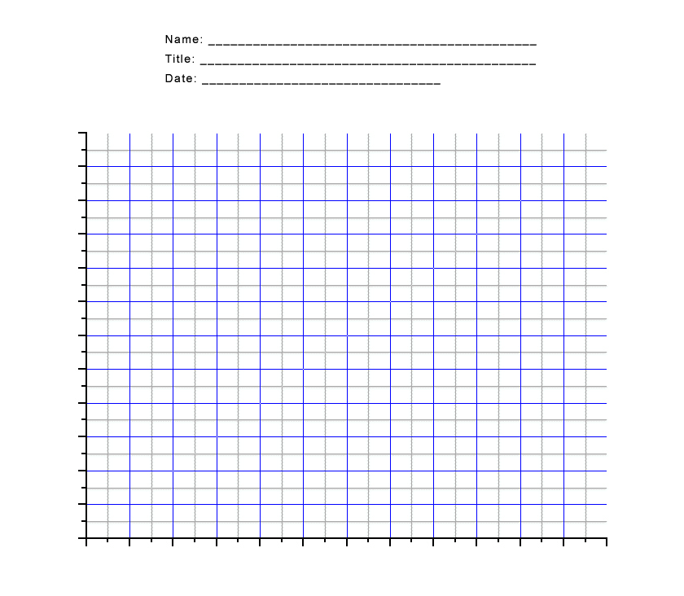

**Size of Shadow (cm)**

60 cm

50 cm

30 cm

20 cm

10 cm

0 cm

40 cm

70 cm

80 cm

90 cm

100 cm

120 cm

110 cm

**Distance From Wall (cm)**

70 cm

50 cm

30 cm

10 cm