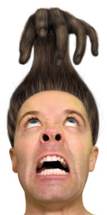**My monster has _______ and _______ hair**

Curly

C:\Users\lambertn\AppData\Local\Microsoft\Windows\Temporary Internet Files\Content.IE5\HFL08X8L\MC900083609[1].wmfStraight

Spikey

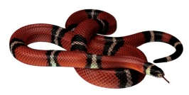Snakey

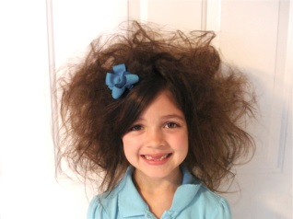Bumpy

Crazy

Scary

Rainbow

Red

Orange

Yellow

Green

Blue

Purple

Pink

Silver

Black

Brown