Station 1

What is a fable?

World Book Article
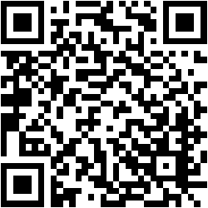
Station 2
Check your understanding!

Donkey Trouble Morals
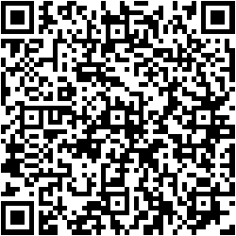

The Ant and the Grasshopper Morals
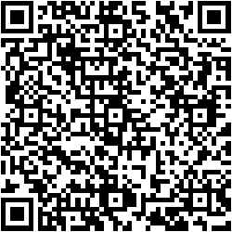

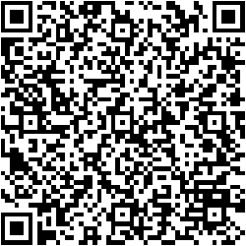
Hare & the Tortoise Morals

Station 3

The Hare & the Tortoise

Station 4

The Ant & The Grasshopper

Station 5

Donkey Trouble

Station 6
Write Your Own Fable

Use one of the Mini Books to write and illustrate your own Fable!

