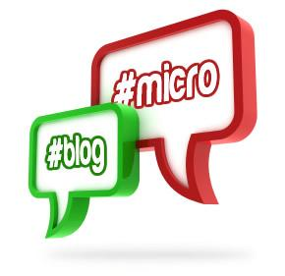
Micro Blogging Station

At this RBE Library Station, you will write a Micro Blog post (like a Tweet on Twitter) to share with others.
Directions:
- Read the prompt on the Micro Blogging poster right outside the library.
- Then take one of the laminated sentence strips from the counter.
- Write your response to the prompt. Be sure to check your spelling and capitalization!
- Place your completed blog post on top of the Holds Shelf so we can post it to our blog poster!

Completed Micro Blog Post Here

